**WEEK-3_EF Core 8.0_LAB2**

Lab 2: Setting Up the Database Context for a Retail Store

Scenario: The retail store wants to store product and category data in SQL Server.

Objective: Configure DbContext and connect to SQL Server.

Steps:

1. Create Models:

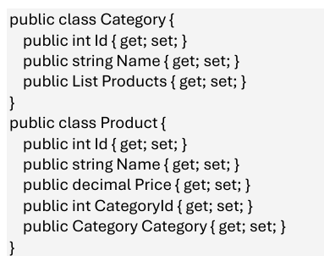

1. Create AppDbContext:

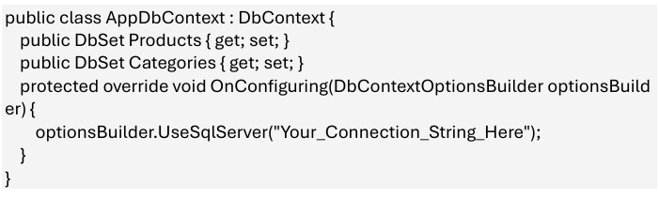

1. Add Connection String in appsettings.json (optional for ASP.NET Core).

**1.Create Models:**

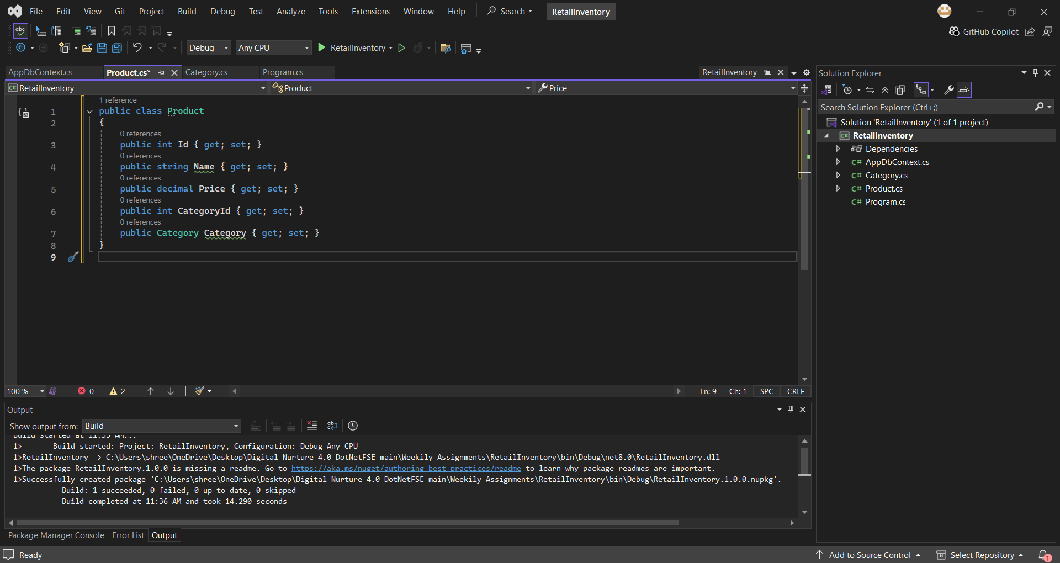

**2.Create AppDbContext:**

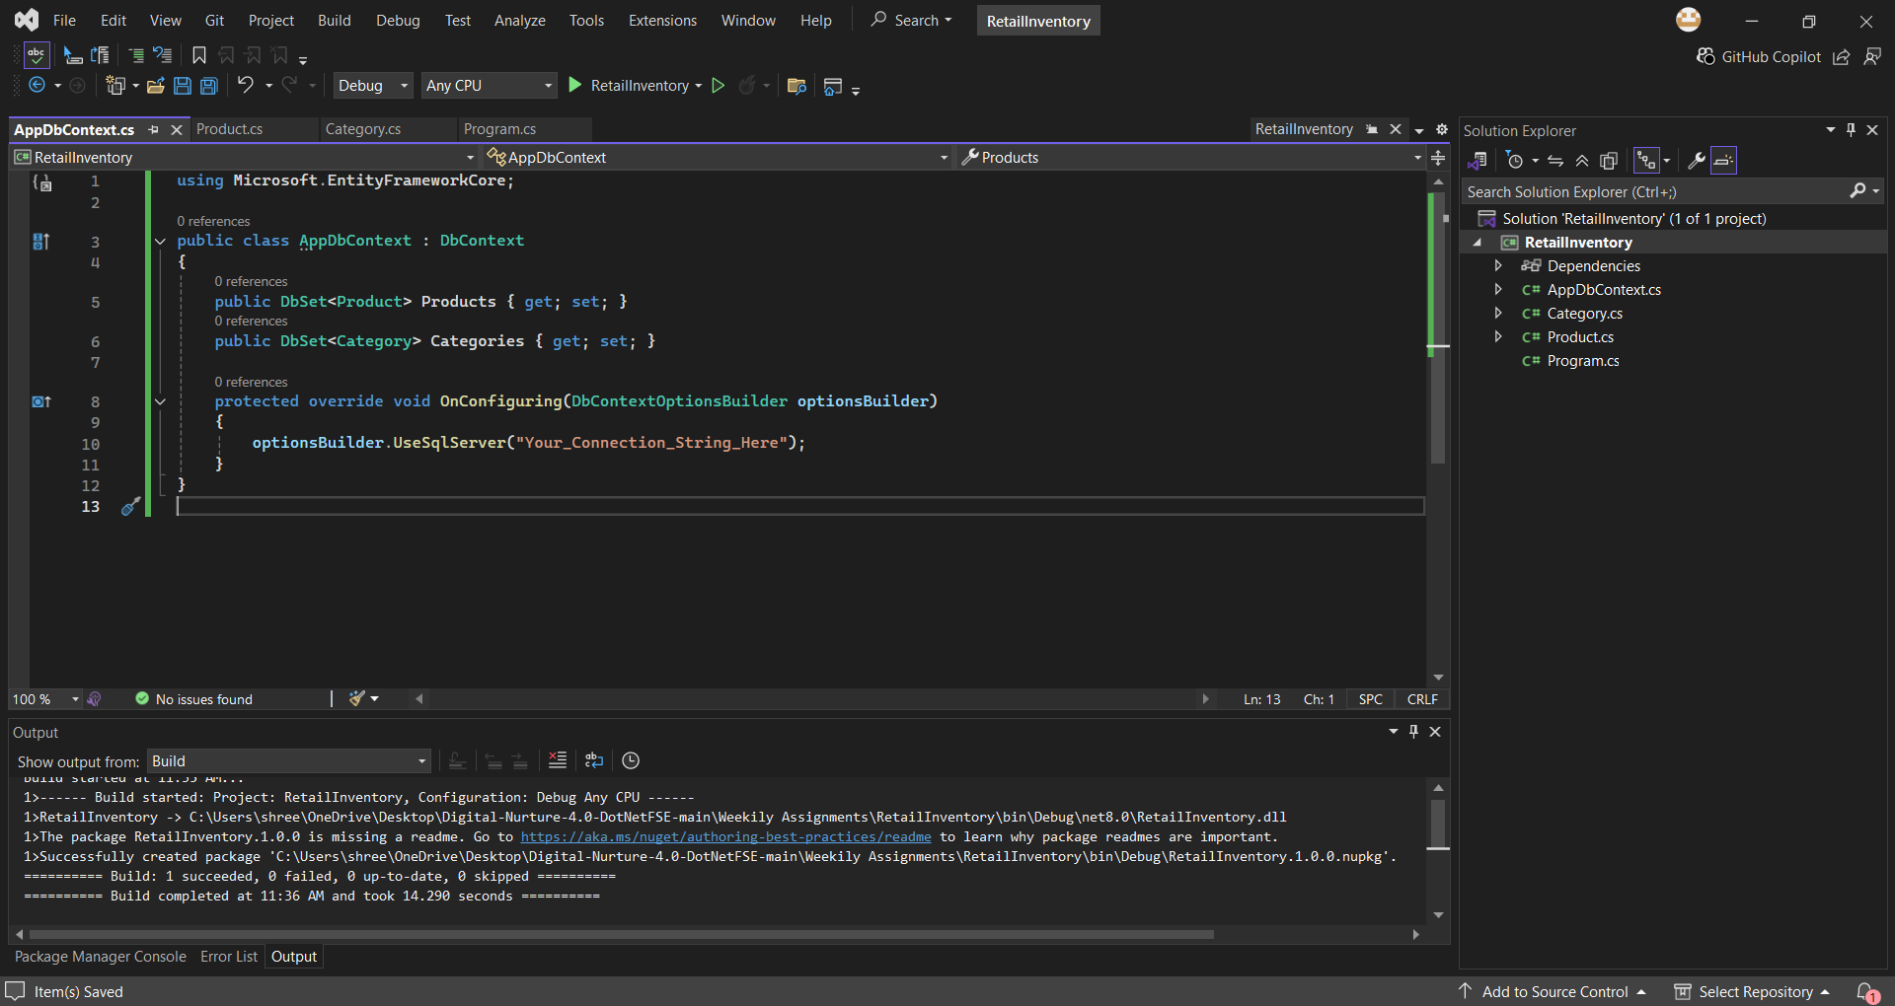

**3.Add Connection String in appsettings.json (optional for ASP.NET Core).**

